**Power BI Project Documentation**

**Project Title: Crop Yield Analysis Dashboard using Power BI**

1. **Objective of the Project**

The main goal of this project is to analyse the **crop yield patterns** across countries and over time, and understand how environmental factors like **rainfall**, **temperature**, and **pesticide usage** impact agricultural productivity. The dashboard allows users (e.g., farmers, researchers, or policy makers) to explore this data interactively and extract meaningful insights.

1. **Data Source Description**

The dataset contains crop yield data for various countries over several years. Key columns include:

* Area: The country or region.
* Item: The crop type (e.g., wheat, maize).
* Year: The year of record.
* hg/ha_yield: Yield in hectograms per hectare.
* average_rain_fall_mm_per_year: Annual average rainfall.
* pesticides_tonnes: Total pesticide usage per year.
* avg_temp: Average annual temperature.

This dataset is realistic and multi-dimensional, making it ideal for building a rich Power BI dashboard.

1. **Data Cleaning & Transformation (Power Query)**

In **Power Query Editor**, the following steps were taken:

* **Changed data types** to ensure numerical columns (e.g., yield, rainfall, temp) are properly recognized for calculations.
* **Removed null or blank rows**, especially those missing critical fields like crop name or yield.
* **Filtered out outliers** — very high or very low values in yield or temperature were examined and excluded if they distorted the analysis.
* **Added custom columns**, such as:
  + **Target Yield** – A benchmark value to compare actual yield.
  + **Efficiency Index** – A calculated field to show how efficiently crops are produced relative to pesticide usage.
  + **Total Yield / Total Pesticides** – For summary analysis.

These steps ensured that the data was clean, consistent, and ready for analysis.

1. **Dashboard Layout and Navigation**

The dashboard follows a **universal layout** for ease of use:

* **Top Cards (KPIs):** Show Total Yield, Average Rainfall, Average Temperature, and Total Pesticides.
* **Left Pane:** Navigation buttons for jumping between pages (e.g., Overview, Yield Analysis).
* **Right Pane:** Two slicers/filters for Area (region) and Crop – to allow focused analysis.

This consistent layout improves the user experience and makes it easy to navigate through the analysis.

1. **Dashboard Pages & Visuals**

***Page 1: Overview Dashboard***

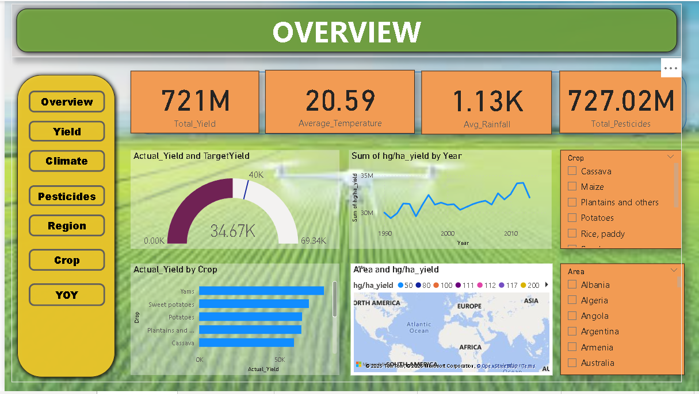

* **Gauge Chart:** Compares actual yield to target yield. This quickly shows whether overall performance is on track.
* **Line Chart (Yield Over Time):** Displays how yield has changed year-by-year. Useful for identifying trends or shifts.
* **Bar Chart (Top 5 Crops by Yield):** Helps users identify the most productive crops in the dataset.
* **Map (Yield by Region):** Geographically visualizes yield, showing which countries/regions are most productive.

***Insight****:* This page gives a high-level summary and is ideal for decision-makers to get a quick sense of performance.

***Page 2: Yield Analysis***

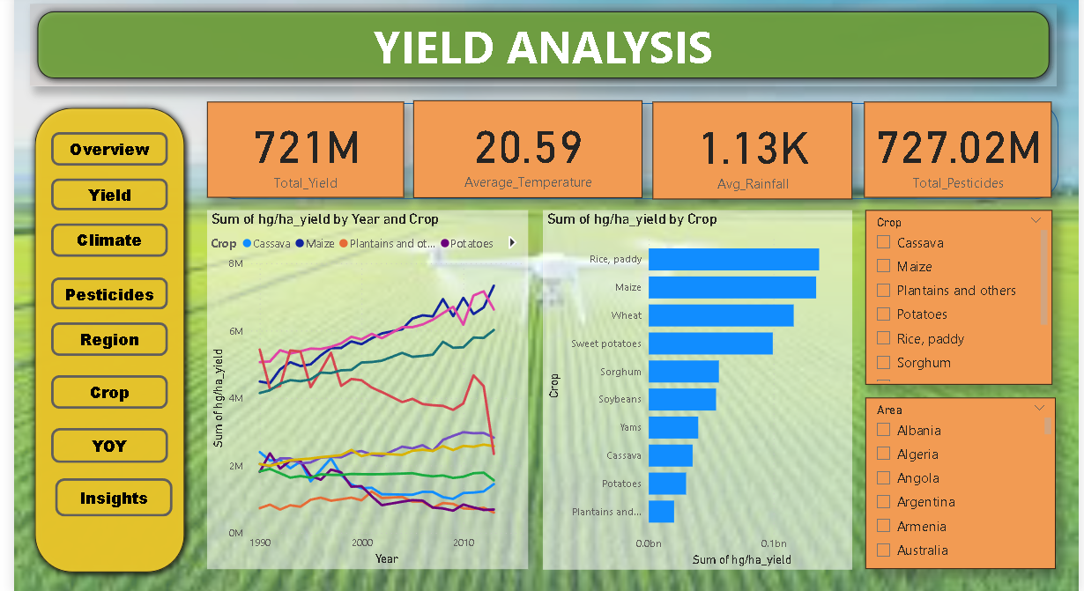

* **Line Chart (Yield by Crop Over Time):** Shows how each crop has performed over the years. Great for identifying consistent performers vs volatile ones.
* **Bar Chart (Yield by Crop):** Provides a sortable view of yields to compare crops directly.

***Insight****:* This page helps users answer: “Which crops are improving?”, “Which ones are declining?”, and “What should we focus on?”

***Page 3: Climate Impact Analysis***

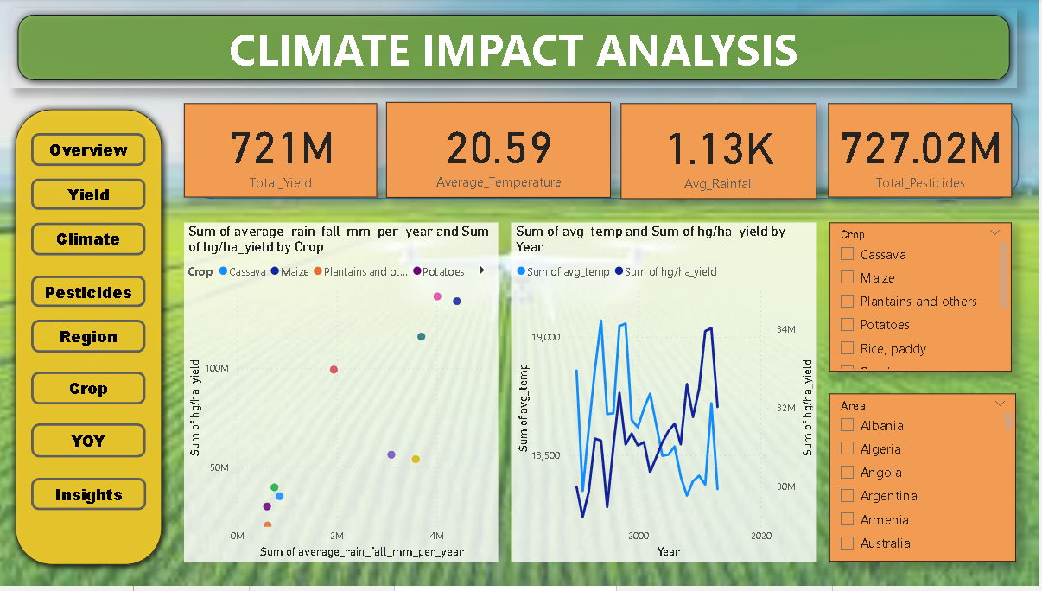

* **Scatter Plot (Yield vs Rainfall):** Shows how rainfall impacts crop yield. Crops are color-coded for easy comparison.
* **Scatter Plot (Yield vs Temperature):** Shows how yield varies with average temperature. Areas are color-coded.
* **Line Chart (Avg Temp vs Yield Over Years):** Helps detect if rising temps are affecting productivity.

***Insight****:* This page is crucial for climate-related decisions. You can see if crops thrive under certain conditions and spot environmental risks.

***Page 4: Pesticide Usage Insights***

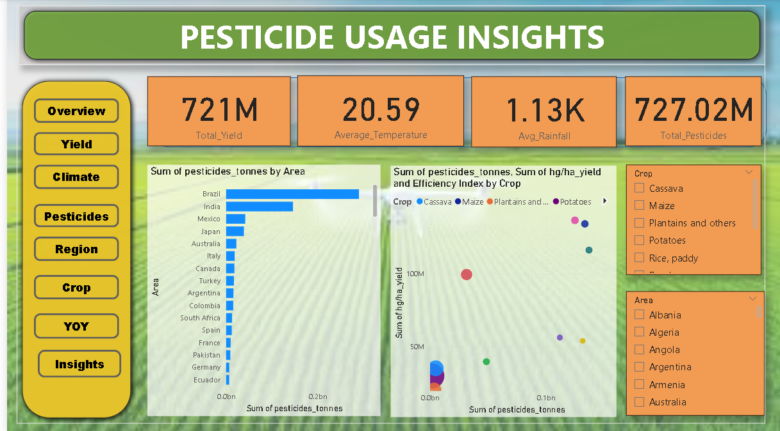

* **Bar Chart (Pesticide Use by Region):** Highlights which regions use the most pesticides.
* **Scatter Plot (Pesticide vs Yield vs Efficiency Index):** A 3-dimensional look at productivity vs chemical input.

***Insight****:* Reveals which crops or regions are high-yield but also high-chemical — a balance point between efficiency and sustainability.

***Page 5: Regional Comparison***

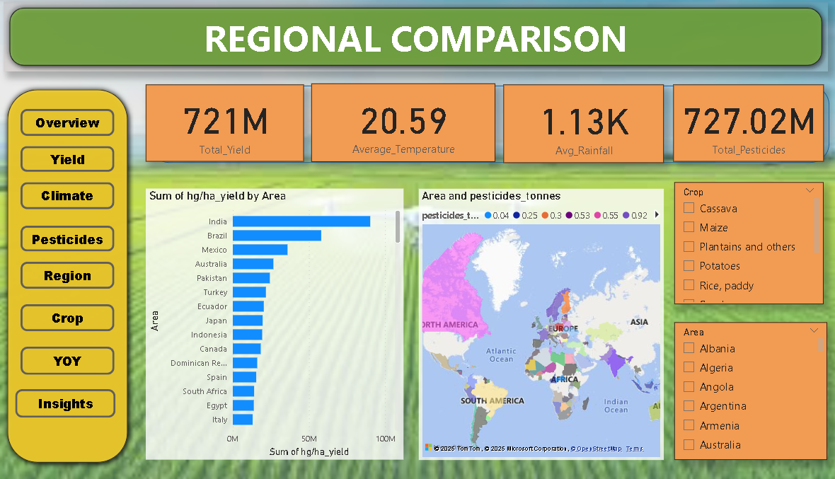

* **Bar Chart (Yield by Crop per Region):** Compares how different regions perform for each crop.
* **Map (Heatmap of Yield):** Shows geographic concentration of crop productivity.

***Insight****:* Useful for comparing performance between countries and identifying region-specific strengths.

***Page 6: Crop Comparison***

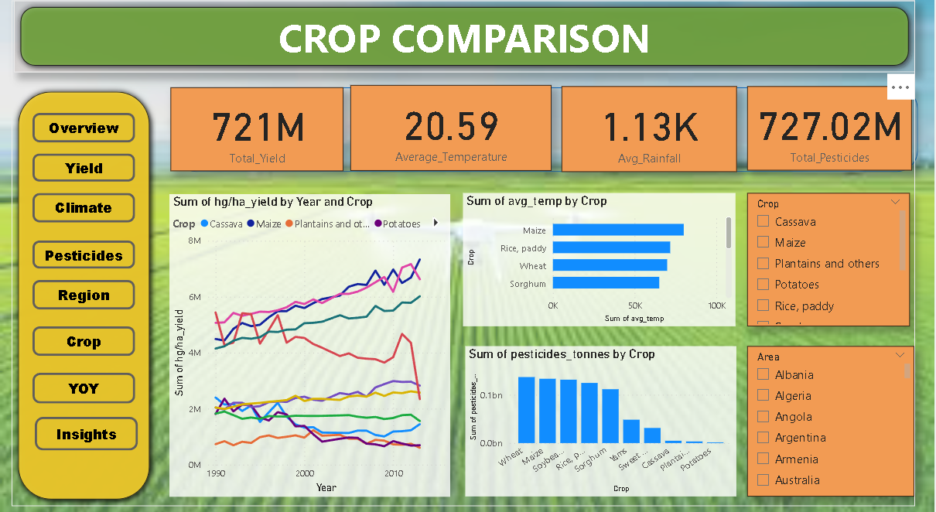

* **Line Chart (Yield by Crop Over Time):** Focuses only on crop comparison, ignoring regions.
* **Bar Charts (Temperature by Crop / Pesticide by Crop):** Compares environmental and chemical needs per crop.

***Insight****:* Shows which crops are more resilient and which require more inputs.

***Page 7: Year-on-Year Trends***

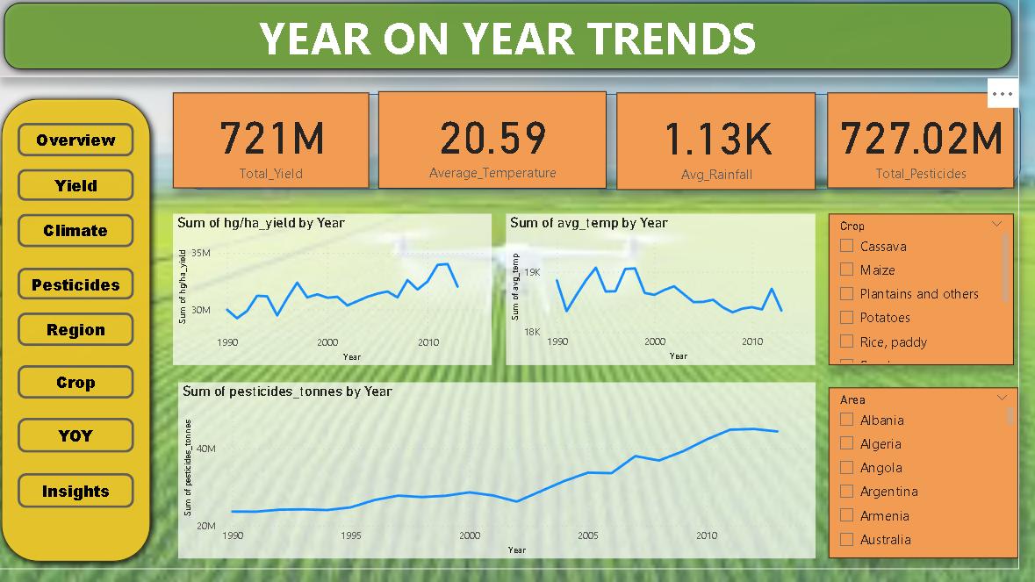

* **Line Chart (Yield Over Time)**
* **Line Chart (Temperature Over Time)**
* **Line Chart (Pesticides Over Time)**

***Insight****:* This page helps track how agricultural variables are evolving over the years.

1. **DAX Calculations**

Basic DAX was used to create:

* **Total Yield** = SUM(hg/ha_yield)
* **Average Rainfall / Temperature** = AVERAGE(rainfall/temp)



* **Efficiency Index** = DIVIDE(Total Yield, Pesticides Used)



No complex DAX functions were used — kept simple and beginner-friendly.

1. **Conclusion**

This Power BI dashboard allows users to:

* Understand crop productivity trends over time
* Explore how climate affects agriculture
* Compare crops and regions to find efficient or underperforming areas
* Make data-driven decisions in agriculture

The dashboard is **interactive**, **cleanly designed**, and useful for both **research** and **practical farming or policy analysis**.